As quoted by Downey, 2015: “A tuple is a sequence of values. The values can be any type, and they are indexed by integers, so in that respect tuples are a lot like lists. The important difference is that tuples are immutable.” Tuples can be very useful when dealing with loops and when paired together with the zip() function, enumerate() function, and the items() method in the dictionary data structure. Below are examples demonstrating the usage of these functions with tuples.

1. Zip Function:
Based on Downey, 2015: "zip is a built-in function that takes two or more sequences and interleaves them. [...] The most common use of zip is in a for loop".The zip() function combines two or more sequences, such as lists, into pairs of tuples. In my own example, I need to pair names with pet types. By grouping the elements into tuples, the code becomes more readable and logically organized.
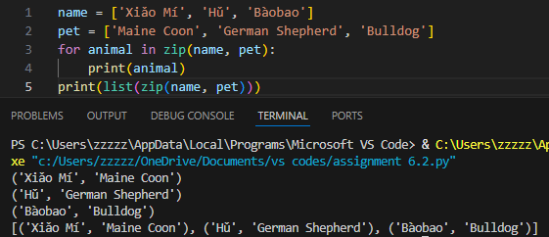In my example, zip(names, pets) pairs each element from the names and pets lists into tuples. The for loop then unpacks each tuple into name and pet, printing them in a formatted string. This produces the output for each pair, making it easier to understand the relationship between names and pets.

- Enumerate Function:
The enumerate() function is used in cases when you require access to both the index and value in a list. The enumerate() function is quite helpful when you want to iterate through a sequence while keeping track of the index of each item. As Downey, 2015, explains: “The result from enumerate is an enumerate object, which iterates a sequence of pairs; each pair contains an index (starting from 0) and an element from the given sequence.” This grouping of index-value pairs is more efficient than manually keeping track of the index. This function is useful when you need both the element and its position in the list simultaneously.
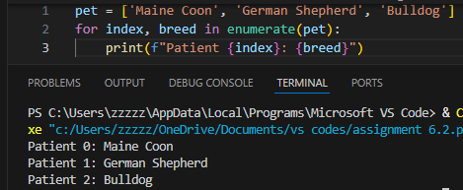
In my example, enumerate(pet) returns an iterator of tuples. Each of these tuples holds the index and its respective pet breed. The for loop unpacks each tuple into index and breed, then prints them in the format "Patient {index}: {breed}". Using enumerate() simplifies the process because it eliminates the need for manually managing the index, making the code cleaner and more concise.

- Items Method for Dictionaries:
According to Downey, 2015: “Dictionaries have a method called items that returns a sequence of tuples, where each tuple is a key-value pair.” This is very useful if you want to work with a key and its associated value at the same time. By working with these tuples, the code remains concise and avoids unnecessary variable management. This makes it easier to iterate over the dictionary and process both parts of the key-value pair without needing additional variables.
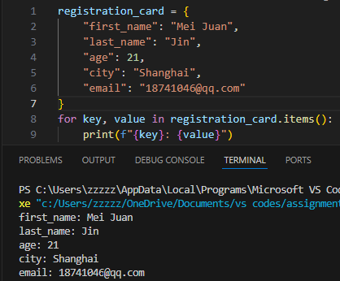
In my example, registration_card.items() returns an iterable of tuples, where each tuple is a key-value pair from the dictionary. The for loop unpacks each tuple into key and value, printing them in a readable format. This makes it easy to process and display both parts of the dictionary at once.

Summary:
With the use of tuples along with zip(), enumerate(), and items(), you can work more efficiently with lists and dictionaries in Python. One of the most significant benefits of using these functions is that they allow you to access both the index and value of elements or pair multiple iterables together, without requiring any additional indexing or any extra variables.

Discussion Question:
Tuples are commonly utilized in Python programming whenever there is a need to return several values from a function or during the iteration of sequences. How have you applied tuples in your own projects, especially with functions like zip(), enumerate(), and items()? What are some potential limitations of using these functions with tuples, and how do you handle those situations?

References
Downey, A. (2015). Think Python: How to think like a computer scientist. Green Tea Press. https://greenteapress.com/thinkpython2/thinkpython2.pdf

